University of Michigan – Dearborn
Department of Computer and Information Science

CIS 285: Software Engineering Tools

Winter 2025 Midterm Exam
Thursday, 02/27, 2:00pm – 3:45pm

Name: Shahbaj Mukul_

ID #: 09727216_________________________________________________________

Instructions:
- Before answering questions, fill in your name and ID number. Before you turn in your exam, sign below testifying that you have neither given nor received aid on this exam. UNSIGNED EXAMS WILL NOT BE ACCEPTED!
- Open book and open note
- No AI tools e.g. ChatGPT etc is allowed during the exam
- No cell phone is allowed, You may use cell phone at the end to take picture of answers you wrote on paper and attach them to the submission.
- No communication tool e.g. discord, is allowed
- Attach cheat sheet to this Word document and only submit this Word document
- Duration: 1 hours 45 mins.

______________________________________________________________________________
Statement on Academic Conduct:

The University of Michigan - Dearborn values academic honesty and integrity. Each student has a responsibility to understand, accept, and comply with the university's standards of academic conduct as set forth by the Code of Academic Conduct, as well as policies established by the schools and colleges. Cheating, collusion, misconduct, fabrication, and plagiarism are considered serious offenses. Violations will not be tolerated and may result in penalties up to and including expulsion from the University.

On Honor, I have neither given nor received aid on this examination

Signature: Shahbaj Mukul
- Use Git commands and Github.com to realize the following process. The exam .zip file contains a java file factorialcalculator.java

  - Create a new local repository
  - Add factorialcalculator.java to the repository.
  - Create a new gitHub repository e.g Midterm
  - Push local to the new GitHub repository
  - Create a local branch ‘YourName’
  - Under ‘YourName’ branch, make whatever change in factorialcalculator.java (you may just change integer num’s value)
  - Compare the difference of the file content and then commit
  - Push ‘YourName’ branch to GitHub
  - Approve and merge the pull request on gitHub
  - Synchronize local Master with gitbub

- List all the commands in the process. Your command must follow the same order as the process. 15 pts
- Copy/Paste your github repository url here (Don’t make any change to the github repository after the exam. It is a cheat if you do so) 10 pts

- Git init
- git add .
- git commit -m “My first java file”
- git branch -M main
- git remote add origin https://github.com/ShahbajMukul/Midterm.git
- git push -u origin main
- git branch newfeature
- git checkout newfeature
- git add .
- git commit -m “added extra text”
- git push -u origin newfeature
- Open github.com -> go to pull requests, create PR, Merge PR, confirm merge.

- Continuing in question 1, Use VSCode, GitHub, and Jenkins to realize the following scenario.
  - Open VSCode and choose Open Folder and navigate to Q1’s folder
  - Under local master branch, use VS Code to modify factorialcalculator.java (You may just change integer num’s value)
  - In VSCode, commit to local master, then push to github
  - Connect to campus VPN and login to
http://141.215.80.187:8090
user name: cis285
password: cis285
  - Create a new freestyle project with the name “YourName_ factorialcalculator”
  - Config the project to connect your Midterm github repository
  - Schedule Build Triggers to poll SCM every minute.
  - Use the following command in Build/Execute Windows batch command
javac factorialcalculator.java
java factorialcalculator

- Repeat step b and c, then have 2 successful builds in Jenkins. Provide these two Console Output screenshots (Don’t make any change to your Jenkins project after the exam. It is a cheat to do so) 25 pts

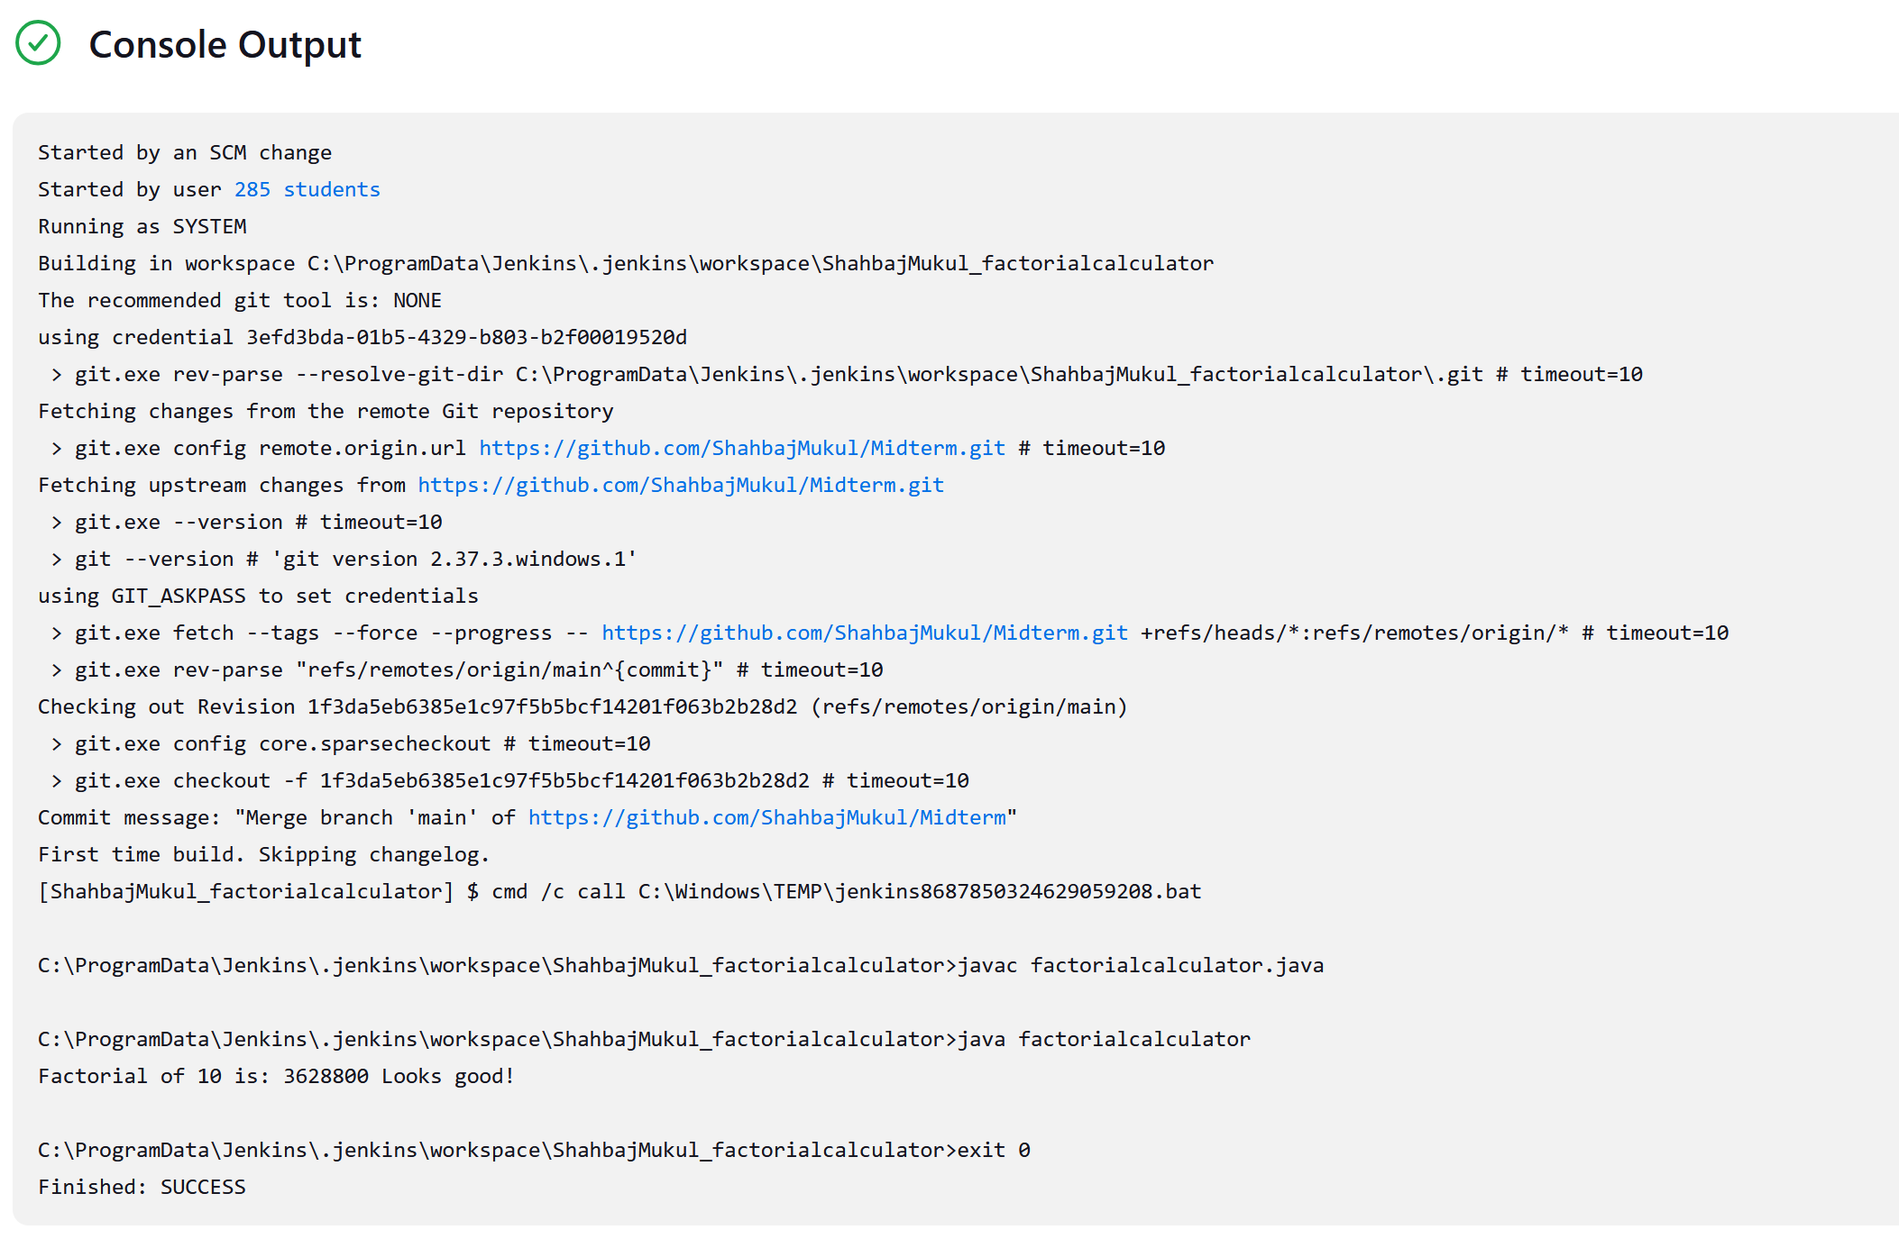
After new commit:
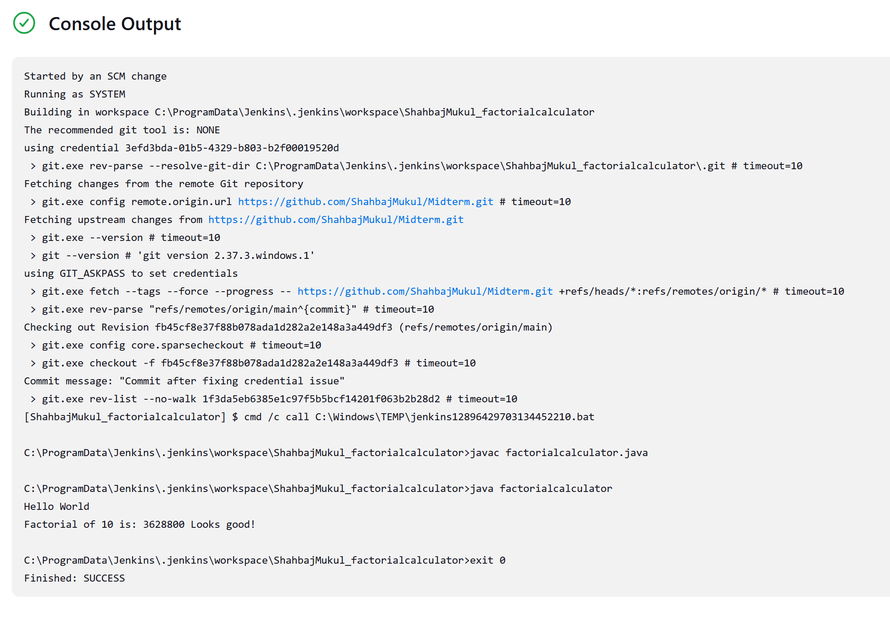

Another test:
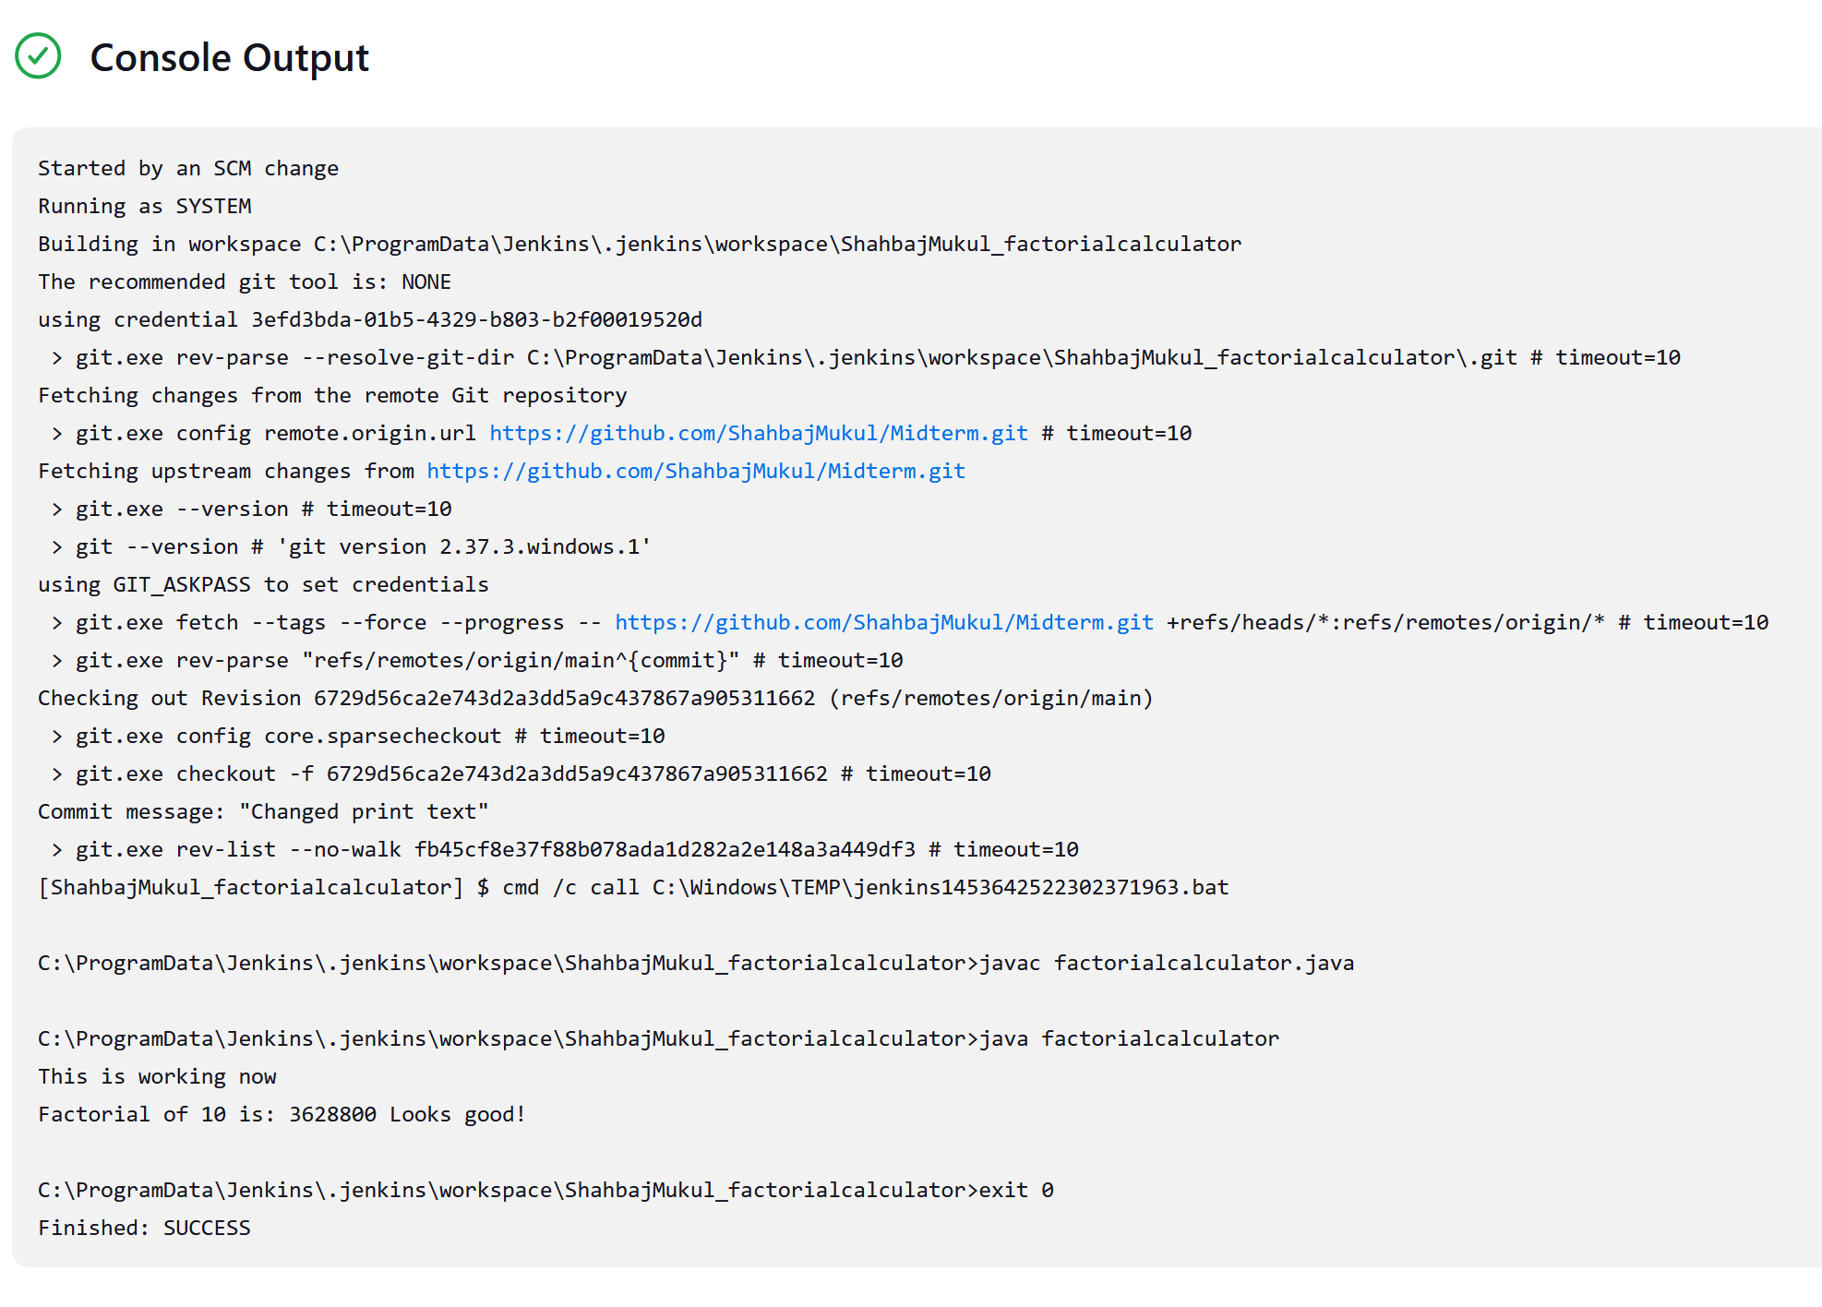
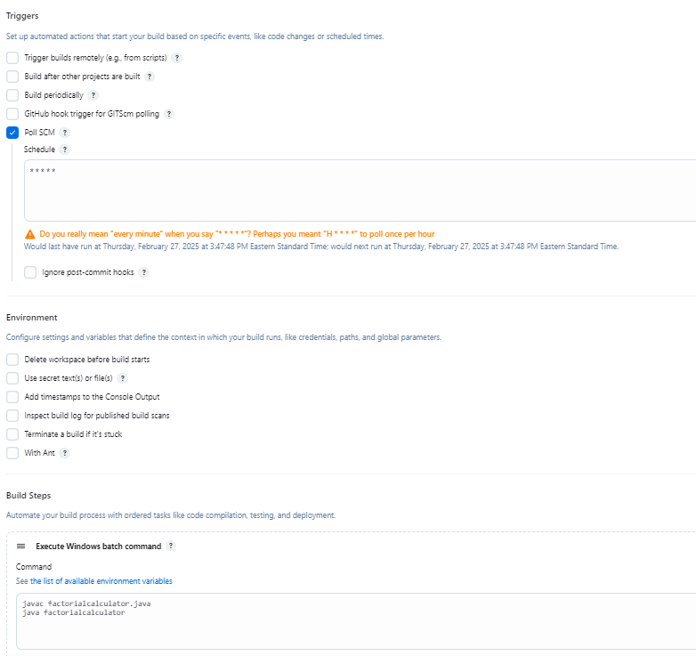

- As a software project manager, you have been asked to compute earned value (EV) statistics for a small software project. At the time of this earned value analysis, 14 tasks have been completed, but according to the project schedule, 16 tasks should have been completed.
The following scheduling data (in person-days) are available:
Compute the Schedule Variance (SV), Cost Variance (CV), Schedule Performance Index (SPI), Cost Performance Index (CPI), and Cost Schedule Index (CSI). (25 pts)
Task | Planned Effort | Actual Effort
1 | 10 | 11
2 | 8 | 9
3 | 12 | 13
4 | 6 | 7
5 | 9 | 10
6 | 14 | 16
7 | 7 | 8
8 | 5 | 5
9 | 10 | 12
10 | 6 | 4
11 | 8 | 9
12 | 13 | 15
13 | 11 | 11
14 | 9 | 10
15 | 12
16 | 7

BCWS = (planned % completed) * PlannedEffort = 87.5 * 147 =12862.5
BCWP = (planned % completed) * ActualEffort = 87.5 * 143 = 12512.5
SV = (BCWP - BCWS) = PlannedEffort = 12512.5 - 12862.5 = -350
CV = ACWP - BCWP =
SPI = BCWP / BCWS = 12512.5 / 12862.5 = 0.973
CPI = BCWP / ACWP =
CSI = CPI * SPI =

- Create a Katalon Testing project to automate flight search on aa.com. 25 pts
  - Create a test case
  - Record and catch objects in aa.com the process to search round trip flight
    - From DTW
    - To NYC
    - Depart 04/05/2025
    - Return 04/08/2025
    - Number of passengers 4
    - Click on Search
  - Clean the task by removing unnecessary steps
  - Rename object whose name is long or contain spaces or you believe not appropriate
  - Define and initialize variables to represent FromCity, ToCity, DepartureDate, ReturnDate and Number of Passengers
  - Add attached FlightData.xlsx to Data file
  - Add For Loop in the scripts to read data from the Excel and do the search.
  - Copy and paste your final scripts below

import static com.kms.katalon.core.checkpoint.CheckpointFactory.findCheckpoint
import static com.kms.katalon.core.testcase.TestCaseFactory.findTestCase
import static com.kms.katalon.core.testdata.TestDataFactory.findTestData
import static com.kms.katalon.core.testobject.ObjectRepository.findTestObject
import static com.kms.katalon.core.testobject.ObjectRepository.findWindowsObject
import com.kms.katalon.core.checkpoint.Checkpoint as Checkpoint
import com.kms.katalon.core.cucumber.keyword.CucumberBuiltinKeywords as CucumberKW
import com.kms.katalon.core.mobile.keyword.MobileBuiltInKeywords as Mobile
import com.kms.katalon.core.model.FailureHandling as FailureHandling
import com.kms.katalon.core.testcase.TestCase as TestCase
import com.kms.katalon.core.testdata.TestData as TestData
import com.kms.katalon.core.testng.keyword.TestNGBuiltinKeywords as TestNGKW
import com.kms.katalon.core.testobject.TestObject as TestObject
import com.kms.katalon.core.webservice.keyword.WSBuiltInKeywords as WS
import com.kms.katalon.core.webui.keyword.WebUiBuiltInKeywords as WebUI
import com.kms.katalon.core.windows.keyword.WindowsBuiltinKeywords as Windows
import internal.GlobalVariable as GlobalVariable
import org.openqa.selenium.Keys as Keys
import com.kms.katalon.core.testdata.ExcelData as ExcelData
ExcelData data = findTestData("FlightData")
def numOfRows = data.getRowNumbers()
def from
def to
def depDate
def retDate
def numP
WebUI.openBrowser('')
for ( def i = 1; i < numOfRows; i++)
{
from = data.getValue("FromCity", i)
to = data.getValue("ToCity", i)
depDate = data.getValue("DepartureDate", i)
retDate = data.getValue("ReturnDate", i)
numP = data.getValue("Number of Passengers", i)
WebUI.navigateToUrl('https://www.aa.com/homePage.do')

WebUI.setText(findTestObject('Object Repository/input_From_originAirport'),
from)

WebUI.setText(findTestObject('Object Repository/input_To_destinationAirport'),
to)

WebUI.setText(findTestObject('Object Repository/input_(date format mmddyyyy)_departDate'),
depDate)

WebUI.setText(findTestObject('Object Repository/input_(date format mmddyyyy)_returnDate'),
retDate)

WebUI.selectOptionByValue(findTestObject('Object Repository/psgr'),
numP, true)

WebUI.click(findTestObject('Object Repository/_flightSearchForm'))
}

